Chapter 10
Design and development of interactive, real time dashboard to understand COVID-19 situation in Pune
Akshata Chaudhari¹ Vaibhav Mankar²⁵² Tejas Wetal³ Sachin Sakhare⁴ Kamal Kant Hiren⁵

¹Dept. of Computer Engineering, akshata.21810198@viit.ac.in
²Dept. of Information Technology, vaibhav.21810282@viit.ac.in
³Dept. of Electronics and Telecommunication Engineering, tejas.21810451@viit.ac.in
⁴Professor Vishwakarma Institute of Information Technology, Pune, India, sachin.sakhare@viit.ac.in
⁵Aalborg University, Denmark, kkh@es.aau.dk

Abstract. The covid-19 have devastated the world through its first and second waves. The different regions in the world react differently to the covid-19 situation. To control the corona virus we need to pay strong attention to the region specific covid-19 situations. In this paper we present the interactive dashboard for the real time monitoring of the covid-19 situation in the pune region. The dashboard displays the daily covid activities ( confirmed cases, recovered cases, etc.. ), covid-19 cases predictions, real time risk index to monitor the risk of third wave, mobility visualization and Current vaccination status. We have conducted a survey, wherein the questionnaire was specifically developed to understand the covid situation along with its psychological impact. We have employed advanced data analysis techniques to analyze the survey results and gather data. Our analysis uncovers the underlying information about the covid-19 in the pune region, the results of the same are presented in the paper. We also present the novel approach for the prediction of region specific covid-19 cases. We hope that our research work helps the locals to better understand the covid-19 situation and motivate other researchers to study the covid-19 in the local regions.

Keywords. Dashboard, COVID-19, Analysis, Vaccination, Mobility, Risk Index, Prediction, Psychological Impact

- Introduction
In the wake of the COVID-19 epidemic, dashboards summarizing large amounts of information have become a topic of public interest. In particular, the interactive web dashboard from Johns Hopkins University has proven to be useful in monitoring the outbreak of the epidemic and keeping billions of people informed of current developments. Such dashboards have helped to visualize key statistics in a knowledge-filled screen and provide visual, practical, and / or analytical features to manage information components effectively.
However, static dashboards do not seem to be enough to account for the growing need to analyze complex and multi-dimensional data at work level.

1.1.1 Dashboard

Dashboard is a visual representation of your data whose primary purpose is to provide information at a glance. It accepts data from a linked database which can be configured as per your needs allowing the viewer to view the data in whichever visualization format he wants.

1.1.1.1 Types of Dashboards

Operating Dashboards - This is the most common type of dashboard, with real-time updated metrics that display data related to daily operations. The main purpose of the operating dashboard is to provide a comprehensive summary of operations, which means you have to enter a large amount of data without having to use multiple drills.
Analysis Dashboards - Use historical data to identify trends that may influence future decision-making. Users should be able to interact with the data in real time mode, so most of them include pivot tables,slicers,dropdown lists and drilldowns. Proper audiences viewing analytics dashboards are site analysts, as they often require a level of understanding that the average business user may not have.
Strategic Dashboards - Follow track to work in relation to your key performance indicators, to better align actions and strategies. If you are looking for a dashboard to share with your entire organization, consider creating a strategic dashboard. Data transparency can lead to increased motivation and other unexpected benefits.

1.1.1.2 Features of Dashboard:

Here are the top six features and benefits of the dashboard:

- Data Transparency - Data is and will be the most important asset of any company. However, it is of little use if no one is able to comprehend or reach it. A well-designed dashboard provides the necessary access to all of your most important metrics.
- Data access - As the name suggests, the dashboard collects various data sources, including Excel, into a single interface. That means you can quickly see all the details of your business with just one quick look. Even better, it reduces the time it takes to compile reports.
- Making better decisions - Dashboards provide an unbiased view of not only the overall performance of the company, but also each department. If each department has access to the dashboard, it can provide the basis for further discussion and decision making. For example, the sales and marketing department may align its data and information to increase customer acquisition and improve demand productivity. Business dashboards offer a good start to such decisions, which is one of the great advantages of dashboards.
- Accountability - While it is always fun to see what you are doing well, you also need to see and understand what you are doing wrong to maximize your performance. Business dashboards can show you exactly where your problem areas are and equip you with the information you need to improve. Also, by making dashboards visible to each and every member of the company , they can respond to both ups and downs of the changing markets.
- Interaction - Some of the best dashboards provide a flexible feel. Instead of providing consistent information, you and your users can filter data, interact with charts to see changes over time, and allow the ad-hoc component to be on track. That means you can get as much or as little detail in certain metrics as you want.
- Gamification - Your metrics, or traffic to your website or marketing products, are important numbers that you want to improve on. Top businesses have been able to create specific business metrics that increase customer retention opportunities. If you are thinking of making a game, business dashboards can track the success of your efforts.
- The ability to identify trends, to measure efficiency, means to produce detailed reports with a single click, the ability to make informed decisions, rapid data identification and relevance.

1.1.2 Outline

Methodology: In this section we broadly discuss and present all the methodologies that have been used for the development of the dashboard, Survey conduction, Data gathering , Data analysis, Prediction system and risk index.

Results: This section we present the overview of the developed dashboard, Results of the survey conducted, Experimental results of the prediction system and Risk index results.

Discussion and Future takeaways: Here we discuss and conclude the research work, we also present some feature takeaways for the further research in this area.

- Methodology
1.2.1 Survey Questionnaires
With reference to new articles, research papers on covid-19 the questions were formed to understand the aspects such as vaccination rate, psychological attitude towards medical treatments and find out the resistance of victim and his/her relatives to the negative news around them.
A form was floated to students residing in the city and responses were collected. If senior citizens of the family wanted to mention their response, respondents were also asked to fill the questionnaire on behalf or help them in the same. Personal details which would reveal the identity of the respondent were not collected.
1.2.2 Data gathering and analysis
The data used here roughly categorized into two classes, data related to the covid activities (like : daily confirmed cases, daily samples etc. ) and data related to the regular activities in the region (like: mobility data, weather data). We have used the indian government organization called as Center of Excellence in Space Sciences India (CESSI)[16], to collect the data of daily covid activities in the pune region.Similarly we have used other data providers like IMD pune[17] for the weather data, Google mobility[18] for the mobility data and Cowin india[24] for the vaccination data.
After gathering the data we preprocess the data to meet our needs. The data processing includes the data cleaning, removing improper values and handling the NaN values. Each type of data goes through the separate data preprocessing operations befour the use. After the preprocessing the data is stored in the database for further use.
The dashboard presented in this paper shows the data in realtime, and thus the data stored in the database has to be updated on a daily basis. We have developed the programs / algorithms to update the data in the database, But essentially the data follows the same procedure as explained earlier before getting appended into the database.
Furthermore we have performed the advanced data analysis to find the underlying information from the datasets we gathered.We have also conducted the comparative analysis of the data, the results of the same are presented in the dashboard. We discuss more on the analysis in the following sections.
1.2.2.1 CESSI data
The cessi data entities are shown in the following table with their description

Sr. Number | Entity Name | Entity Description
1 | dailysamples | Daily samples taken
2 | dailyconfirmed | Daily confirmed cases
3 | dailyrecovered | Daily recovered cases
4 | dailydeceased | Daily deceased cases
5 | totalcritical | Total critical cases till date
6 | totalsamples | Total samples were taken to date
7 | totalconfirmed | Total Confirmed cases till date
8 | totalhospital | Total hospitalized patients till date
9 | totalrecovered | Total recovered cases till date
10 | totaldeceased | Total deceased cases till date
11 | active_hosp | Patients active in hospital
12 | active_home | Cases home isolated at home

Table 1.2.2.1.1
1.2.2.1 Vaccination
The vaccination data is gathered from the Co-WIN[24] portal of the government of india. We provide the important insights for the vaccination status of the pune region as described in the following table.

No. | Category | Description
1. | Weekly vaccination | Dose wise( 1st and 2nd) Vaccination completed in a week
2. | Weekly Age Wise vaccination | Age wise ( 18-44,45-60,60+) Vaccination completed in a week
3. | Weekly registration | Total registration done in a week
4. | Vaccination by age | Overall “Vaccination by age” done till date
5. | Centerwise vaccination | Vaccinations done by each centers in pune
6. | Centerwise vaccination coverage(Total) | Total vaccination coverage
7. | Vaccination by category(urban/rural) | Urban and rural Vaccination done in pune

.Table 1.2.2.2.1
The real time visuals of the vaccination data have been displayed in the dashboard.
1.2.2.3 Mobility
The mobility data report presented by google contains the global data, from the global mobility data. We have extracted the Pune region specific data as well as the maharashtra state mobility data. Pune region specific mobility data is used for the training of the prediction model and for the realtime predictions. Maharashtra state mobility data is presented in the dashboard for the thorough analysis of the mobility throughout the state of Maharashtra..

1.2.2.4 Mobility Analysis

Google mobility data[198contains data from google maps, google users who have turned on the Location History. We created charts from the data to analyze the data thoroughly. Those Charts denote the movement trends over time by geography, across different categories of places such as retail and recreation, groceries and pharmacies, parks, transit stations, workplaces, and residential which display the change in visits to those places. Parks typically means official national parks and not the general outdoors found in rural areas.The baseline day is the median value from the 5‑week period ( Jan 3 – Feb 6, 2020) . If the percent change is positive, that means mobility trends increase from the baseline.While If the percent change is negative, that means mobility trends decrease from the baseline.

Description of the columns from Google Mobility dataset :

Column names | Description
retail_and_recreation_percent_change_from_baseline | Mobility trends for places like restaurants, cafes, shopping centers, theme parks, museums, libraries, and movie theaters.
grocery_and_pharmacy_percent_change_from_baseline | Mobility trends for places of grocery and pharmacy.
parks_percent_change_from_baseline | Mobility trends for places like local parks, national parks, public beaches, marinas, dog parks, plazas, and public gardens.
transit_stations_percent_change_from_baseline | Mobility trends for places like public transport hubs such as subway, bus, and train stations.
workplaces_percent_change_from_baseline | Mobility trends for places of work.
residential_percent_change_from_baseline | Mobility trends for places of residence.

Table 1.2.2.4.1
Mobility trends in Maharashtra in the year 2020

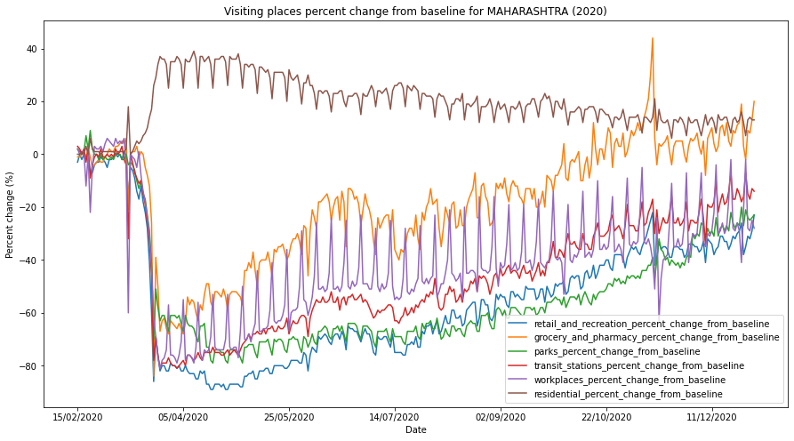

Figure 1.2.2.4.1

Mobility trends in Maharashtra in the year 2021

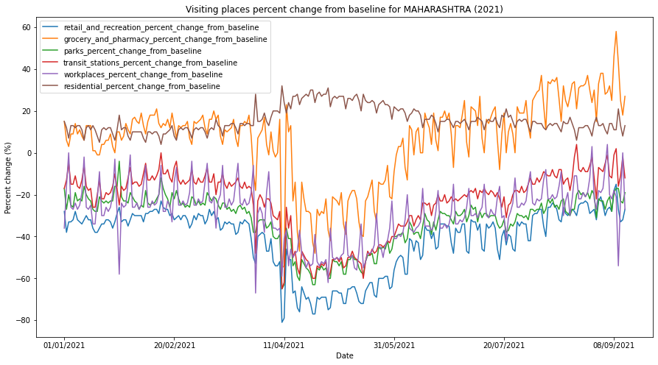

Figure 2.2.4.2

On comparing the above two graphs of mobility trends of Maharashtra from the year 2020 and 2021, We found that residential places mobility was greater in 2020 than in 2021 which could have been a result of the lockdown imposed . Grocery and pharmacy mobility was too low in 2020 than in 2021 that implies lockdown was a great option to control the spread of the epidemic as people were not going much in medicals, hospitals in that period because of less contraction of Covid-19. When mobility around places like transit stations, workplaces, retail and recreation places and parks increases, Covid-19 cases also increase. Similarly we analyzed different regions from Maharashtra along with Pune and we added those charts for better understanding in the dashboard.

1.2.2.5 Weather and Risk Index Relation

We gathered weather data for the Pune region from the IMD (Indian Meteorological Department) data provider.
Description of the entities in the weather dataset :

Sr. Number | Entity Name | Entity Description
1 | SLP in hPa | Sea level pressure in hectopascal
2 | Tmax | Maximum temperature of that day
3 | Tmin | Minimum Temperature of that day
4 | Rain_in_mm | Rain measured in millimeter
5 | Rh_in_% | Relative Humidity in Percentage
6 | Wind_Direction | The direction of the wind
7 | Wind_Speed(kmph) | Wind speed in kilometer per hour

Table 2.2.5.1

We gathered this data from 15th March 2021 to 14th September 2021 and we observed the following minimum and maximum values for each entity/parameter.

Parameters | Minimum value till 14th Sept 2021
SLP_in_hPa | 936
Tmax | 25
Tmin | 14
Rain_in_mm | 0
Rh_in_% | 12
Wind_Direction | 24
Wind_Speed(kmph) | 0

Table 2.2.5.2

Parameters | Maximum value till 14th Sept 2021
SLP_in_hPa | 948
Tmax | 40
Tmin | 24
Rain_in_mm | 6408
Rh_in_% | 97
Wind_Direction | 328
Wind_Speed(kmph) | 14

Table 1.2.2.5.3

By observing and analysing above values, we can conclude that when sea level pressure is 943 hPa, maximum temperature ranges from (31 to 37[mainly 31,33,37])℃, minimum temperature is (20 or 22 or 23)℃, rain measured in millimeters is (0 or 860)mm, relative humidity ranges from(48 to 69[mainly 48,63,69]), (verified from news articles and papers [31] [32]), wind speed ranges from (5 to 9 [mainly 5,9])kmph, there is a risk for Covid-19 third wave to occur. When above values are present, there will be medium to high risk for the third wave.
In the above table, wind direction ranges from 235 to 251. By referring to the below table, we can say that, when wind direction will be in SW and WSW, there will be more chances of a third wave.

Table 1.2.2.5.4 showing wind direction and their respective values :

SSW(South-South West) | 191.25 - 213.75
SW(South west) | 213.75 - 236.25
WSW/(West-South West) | 236.25 - 258.75
[25]
Table 2.2.5.4

After this, we compared that data with the risk index calculated by using method 2 (refer to the point 2.4.2) and we found that on the medium to high risk level days, some values of the IMD data parameters were either same or repetitive.
Enlisting the values of parameters on medium to high risk level days below :

Parameters | Values on medium to high risk level days
SLP_in_hPa | 942,943,944
Tmax | 26,30,31,32
Tmin | 20,21
Rain_in_mm | 0,1,2,4,294
Rh_in_% | 61,62,69,81,86,88
Wind_Direction | 201,227,246,250,251,253
Wind_Speed(kmph) | 2,4,5,6,9

Table 1.2.2.5.5

By observing and analysing above values, we can conclude that when sea level pressure is (942 or 943 or 944)hPa, maximum temperature ranges from (26 to 32[mainly 26,30,31,32])℃, minimum temperature is (20 or 21)℃, rain measured in millimeters is (0 to 4 or 294)mm, relative humidity ranges from(61 to 88)%, (verified from news articles and papers [31] [32]), (wind speed ranges from (2 to 9 [mainly 2,4,5,6,9])kmph, there is a risk for Covid-19 third wave to occur. When above values are present, there will be medium to high risk for the third wave.
In the above table, wind direction ranges from 201 to 253. By referring to the table no.Z, we can say that, when wind direction will be in SSW, SW and WSW, there will be more chances of a third wave. In short, when the wind direction is between South and West, there could be the possibility of a third wave.

1.2.3 PREDICTION SYSTEM

After data cleaning, we combine all the data sets and develop the final dataset used for the training of the model.
Here we have developed several models for the prediction of the covid-19 cases in Pune city. The models are broadly divided into two parts: single output and multi-output models. In single output models, we have used linear model[1], feed-forward neural network[2] (dense Neural network), Convolution neural network[3]-based model, and Recurrent neural network[4] model. The multi-output model is the autoregressive model[5] developed based on the Long and Short Term memory architecture(LSTM)[6]. We will discuss this model in the following sections.

1.2.3.1 Model-data preparation

All the features of the dataset are fed to the model in fixed-sized batches. The feature contains all columns as shown in the tabel 1.1 . The “daily_confirmed” is the label column that we want to predict. All the data is normalized before feeding to the model to ensure the data scale independence and to make the model computationally less expensive.

The model takes the last 30 days’ information and based on it, it predicts the next day value for the daily_confirmed. The data is presented to the model in the form of the window[7] iteratively. Similarly in the multi-output model, the model takes the last 30 days’ input and predicts for the next 7 days.

The shape of the input data is (Batch size , timestamp, features )
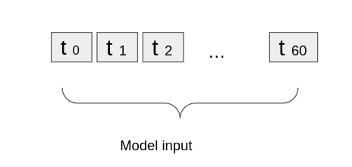
Figure 1.2.3.2.1

1.2.3.2 Single output models

In the single output model, the input to the model are features of the last 30 days and the output of the model is the prediction of the next day covid cases.

1.2.3.2.1 Linear Model

The linear model is the simplest form of the model that learns the mapping through a linear function[8]. We consider the linear model as the baseline[9] for the performance check of the rest of the models. The linear model takes the last 30 days’ input and based on a simple linear function, it learns the mapping from feature inputs to the next day’s predictions.
The linear model is implemented using the TensorFlow dense layer with only one compute unit in it.

1.2.3.2.2 Feed-forward neural network (FNN)

Here we implement the simple feed-forward neural network with few hidden layers creating a standard towered structure model[10]. The input data is first converted into a single-dimensional vector and that single-dimensional vector is fed to the model. The model has five layers, an input layer, three hidden layers, and one output layer. The hidden layers have a 128:64:32 structure and each layer uses the rectified linear unit activation function[11] to learn the complex nonlinear mapping from input to output.
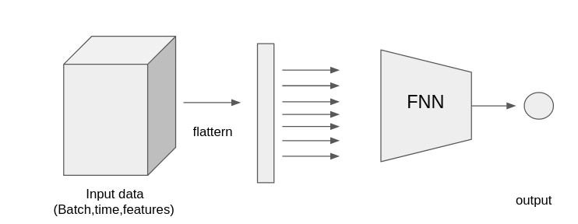

Figure 1.2.3.2.2.1

1.2.3.2.3 Convolutional neural network (CNN)

As the input is three-dimensional here we can also use the convolutional neural network. That takes the three-dimensional data ( batch, time, features ) as input and performs the standard convolution operation[12]. Similar to the previous Feedforward neural network model, we use a last series of dense layers of the neural network here but the dense layers are presented on top of the convolution layer. The convolution layer consists of 32 filters and a rectified linear unit activation function.

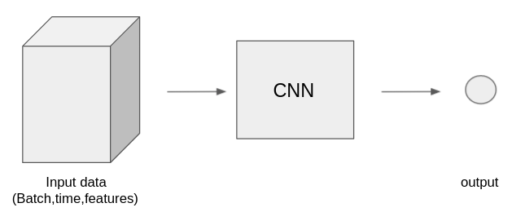

Figure 1.2.3.2.3.1

1.2.3.2.4 Recurrent neural network (RNN)

A recurrent neural network is mostly used for the time series data as this network processes the data one-time stamp at a time while keeping the information from the previous timestamps. Most of the NLP[13]-based applications are based on the RNN. The network does not only focus on the input timestamps but also focuses on the internal relations between the time stamp, in this case, the relation between the features / covid data entities of a particular day with features from other days. Here In this paper, we have used the Long short-term memory (LSTM) based RNN.

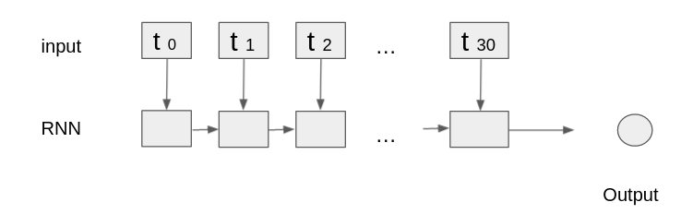
Figure 1.2.3.2.4.1

1.2.3.3 Multi-output model

The multi-output model is similar to the single output model, here we are specifically using LSMT-based RNN for the prediction. Unlike the single output model, the multi-output model produces multiple outputs, i.e instead of predicting the next day’s cases of the corona, in the multi-output model we predict the next “n” number of days ( next 7 days ).

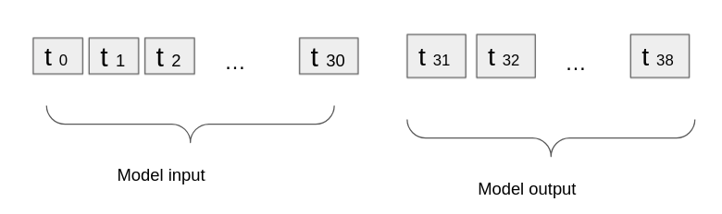
Figure 1.2.3.3.1

1.2.3.3.1 Autoregressive model

Here we have developed an autoregressive model for predicting the covid cases of multiple consecutive days. The autoregressive method can be applied to any model that can predict the next day’s value, in other words, any single output model can be converted into the multi-output model by using the autoregressive technique. Here we have experimentation with the various techniques in the single output model and the best performing one is used of the multi-output model with the help of autoregressive technique. The autoregressive techniques are commonly found in sentence generation[14], next word generation[15], and other well-known NLP applications. Hereafter experimenting with various single output models we have found that the LSTM based RNN model outperforms every other model we experimented with, and hence we have chosen the LSTM based RNN model for the prediction of multiple consecutive days, we will discuss more on this in the next section.

1.2.3.3.2 LSTM-RNN autoregressive model

As we have seen the working of a simple LSTM based RNN model in section 2.3.2.4 The working of the autoregressive model is similar to that. Here the input to the model is the last 30 days data but the output of the model is fed back to the model and thus the model generates one more output and we do this iteratively until we get the desired length of the output, i.e 7 days. one might assume that the simply trained single output model is sufficient to generate n number of predictions by using the same mode iteratively and thus there is no need to train a separate model to perform the same, however, when we do this the multi-output model’s performance is entirely depended on the single output model and hence we are not introducing any new learning to the model even though the purpose of the model is completely new.
To solve this we fix the number of output days ( i.e 7 days ) and train the new model using the autoregressive technique. This way the model has more information on the output, therefore during the training model can learn and adjust the weights to perform the task more efficiently.

1.2.3.3.3 LSTM-RNN autoregressive model architecture

The model architecture is similar to the single output RNN but here we introduce the feedback loops which feed the output of the model back to the model and help the model to learn better.

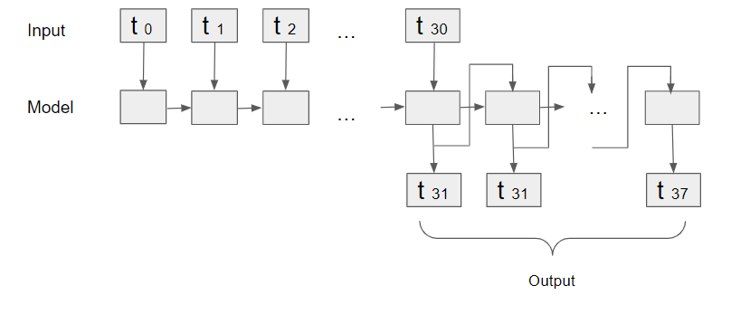

Figure 1.2.3.3.3.1

And thus we have trained all the models and results of these are added in the results section

1.2.4 RISK INDEX

Risk index (RI) gives the measure of the risk for the covid-19 3rd wave. Looking at the current situation of covid-19 in Pune, it is needed to find out the risk index for the covid-19 third wave for Pune. It can be calculated by using two methods. The existence of two independent methods adds robustness to the calculation of the risk index.

Method - 1 | Calculating RI and threshold
Method - 2 | Calculating RI without using threshold

The prediction model is based on a Recurrent Neural Network (RNN) with Long Short Term Memory (LSTM). Though recurrent neural networks are often used in time series forecasting, they have a problem where the weights of past data are lost due to the vanishing gradient problem. The solution of this problem is to add Long Short Term Memory to the RNN architecture. For calculating the risk index, we need predicted values and for that we used RNN with LSTM.

1.2.4.1 Method 1 - Calculating risk index and threshold

Risk index is the relative difference between actual values of daily cases and predicted values of daily cases. It is calculated using the following equation:

$Risk Index for each day =\frac{Daily actual cases - Daily predicted cases}{Daily predicted cases}$ ..(1)

By using the above formula, we calculated the risk index for each day.

Covid-19 first wave occurred in Pune from 9th March 2020 to 31st October 2020. Then there was a maintenance phase between 1st November 2020 to 14th February 2021 and a second wave occurred in Pune from 16th Feb 2021 to 7th June 2021 as mentioned in “Indian Express” news article.
Threshold is the limit for the risk index above which there is high risk and below which there is low risk. For calculating the threshold, it needs values from the first wave and second wave. Data we gather from cessi website has data from April and for prediction it takes at least 30 days. So we took data for the first wave from 14th May 2020. Rest duration has been taken the same. The change of 1-2 months will not hamper that much on calculation of the threshold as the difference will be of a few points.

Later we calculated following values for Pune from the data:

 | Total actual cases | Total predicted cases
First wave | 158362 | 144687.1787
Second wave | 277244 | 241485.6351

Table 1.2.4.1.1

$Risk index for the first wave =\frac{Total actual cases in the first wave - Total predicted cases in the first wave}{Total predicted cases in the first wave}$ ..(2)

$Risk index for the second wave=\frac{Total actual cases in the second wave - Total predicted cases in the second wave}{Total predicted cases in the second wave}$ ..(3)

By applying above formulae, we got following values:

RI for the first wave = 0.0945130136

RI for the second wave = 0.1480765714

Based on the relative differences between the actual and predicted values between the first and the second wave, the threshold for the possible onset of the third wave for Pune is determined as follows:

$Threshold = \frac{RI for the second wave - RI for the first wave}{RI for the first wave}$ ..(4)

By applying above formula of threshold, we got following value of threshold:

Fixed threshold for Pune = 0.5667320907

The threshold value will not be changed. The value is fixed for Pune. If the risk index is less than the threshold, the probability of a wave is low but if the risk index is consistently more than the threshold, the probability of a wave is high.

Lets say,
RI = Risk Index for each day

AC = Daily actual cases

PC = Daily predicted cases

T = Threshold

By using equation (1),
RI = (AC - PC)/PC ..(5)

but if there are no chances of a third wave, RI should be less than the threshold.

i.e. RI < T

Let's put equation (5) in place of RI. The equation will become,

(AC-PC)/PC < T

hence , AC < (T * PC) + PC ..(6)

As we have values of T and PC , we can easily calculate the right side of the equation.That is nothing but the actual case limit. i.e. (T * PC) + PC.
There is a specific limit assigned to actual cases for each day.
If actual cases exceed the limit, then there will be the possibility of Covid-19 wave.

1.2.4.2 Method 2 - Calculating risk index without using threshold :

For calculating the risk index using this method, we need values for X and Y which can be calculated using below formulae :

$X=100\frac{Daily actual cases - Daily predicted cases }{Daily Predicted cases}$ ..(7)
$Y = 10\frac{1}{1+\frac{Daily actual cases}{Total predicted cases}}$ where, total predicted cases = sum of predicted cases ..(8)

If Y > 8, then the Risk Index will be Y + X. Otherwise it will be X.

In this way, the risk index will be calculated.

When the Risk Index is greater than 10, the risk for the 3rd wave becomes statistically compelling. The 7.5 and 10 risk indexes correspond to medium and high risk, respectively. While 0 risk index corresponds to low risk and less than 0 risk index corresponds to very low risk.

RISK INDEX | RISK
0 | Low
7.5 | Medium
10 | High

Table 1.2.4.2.1

1.2.5 DASHBOARD DEVELOPMENT

The dashboard UI was developed using the Google data studio[19], the google data studio provided the interface for building the dashboard. After the data gathering and preprocessing we have stored the datasets into four different files namely daily data, prediction data, Mobility data and Risk index data. All the data is independently monitored and updated using our server side application developed with python[20] and flask[21].

To store the data we have used google spreadsheets[22] and to monitor and update the data we have developed a separate server side application that is deployed on the herokuapp[23] server. The data in the database is updated daily to reflect the changes in the real world.The spreadsheet database is connected to the google data studio such that any changes in the spreadsheet database gets reflected into the dashboard that makes our dashboard work in real time.

Finally we have published the dashboard using the heroku app server. The dashboard “Pune Co-WE Board” is presented in the website that is accessible to everyone.

1.3. RESULTS

1.3.1 SURVEY

According to the survey:

- 62% of the respondents are male and 38 % of the respondents are female.
- 64% citizens reside in urban areas, 24 % in suburban areas and rest in rural areas.
- Fever, cough,body ache,cold,headache and absence of smell and taste were the primary symptoms accounting to 44%,38%,32%,24%,20% respectively.
- 30% are sure that they have visited a hotspot area/ covid infected patient.
- 38% are not sure what was the reason for their symptoms.
- A whopping of 86% citizens have opted for Covishield vaccine and 70% have completed both the doses.
- 14% have contracted covid even after receiving both the doses.
- Around 65% were home isolated and have taken the prescribed medicines.
- Out of the above home isolated condition of around 14% people did worsen during the isolation phase and were hospitalized for the same.
- 26% of the responders feel that not being in touch with the patient and lack of positivity to recover was the reason that the patient succumbed to covid.
- While 20% feel that the patient had a medical history before getting infected with covid.

1.3.1.1 Graphical representation of the survey results

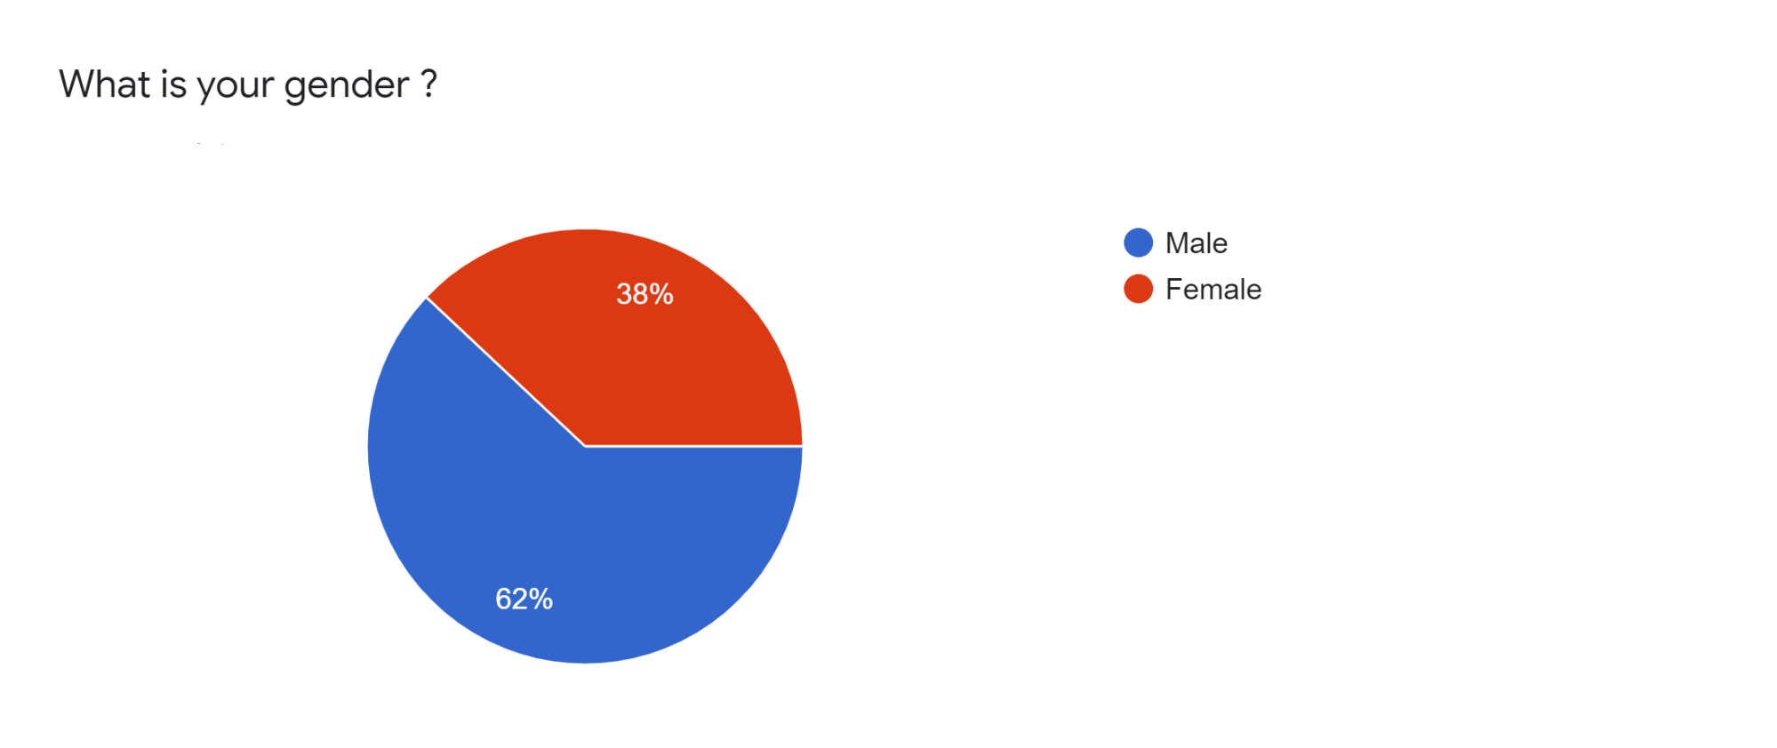
Figure 1.3.1.1

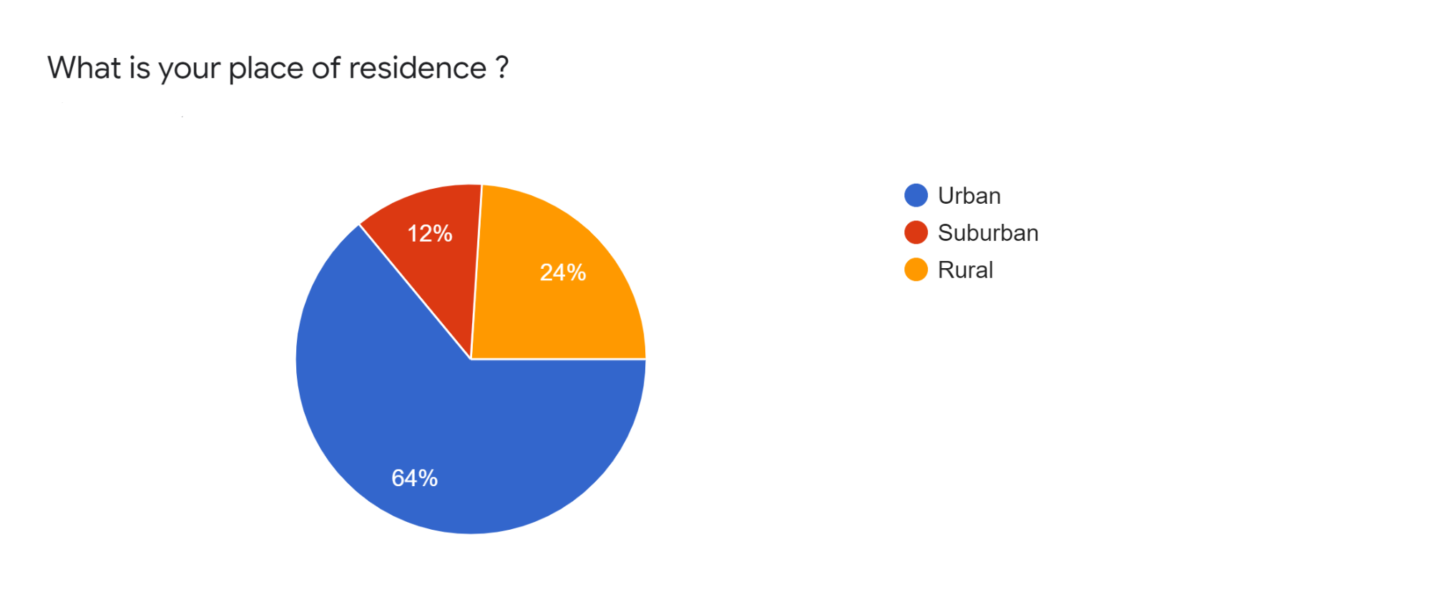
Figure 1.3.1.2

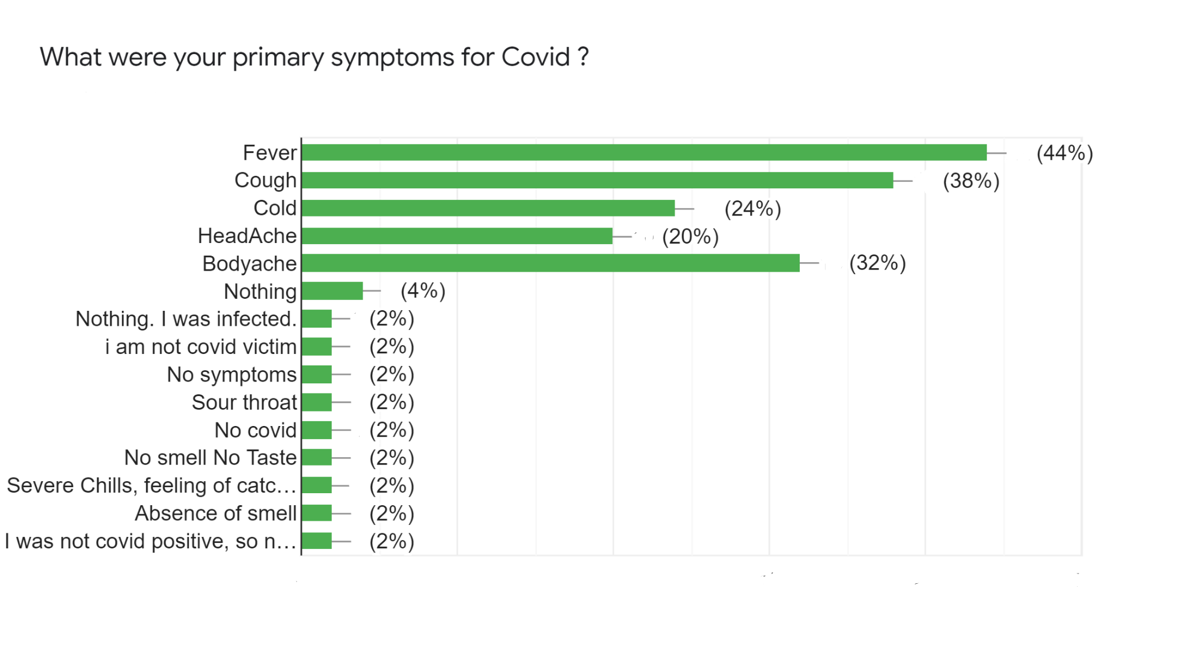
Figure 1.3.1.3

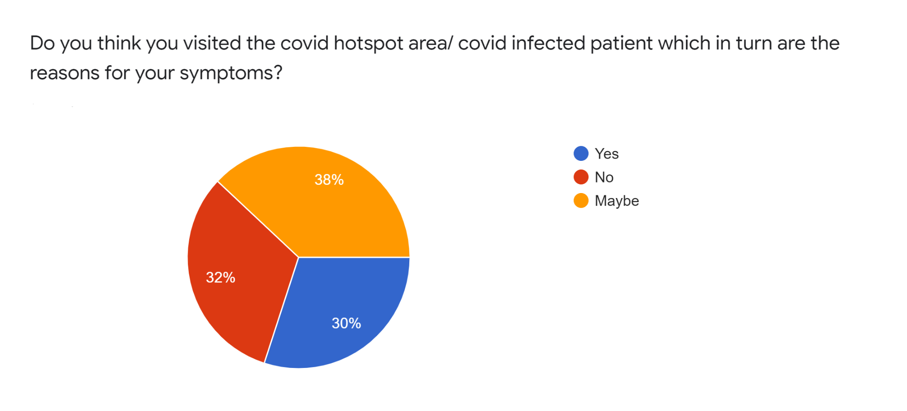
Figure 1.3.1.4

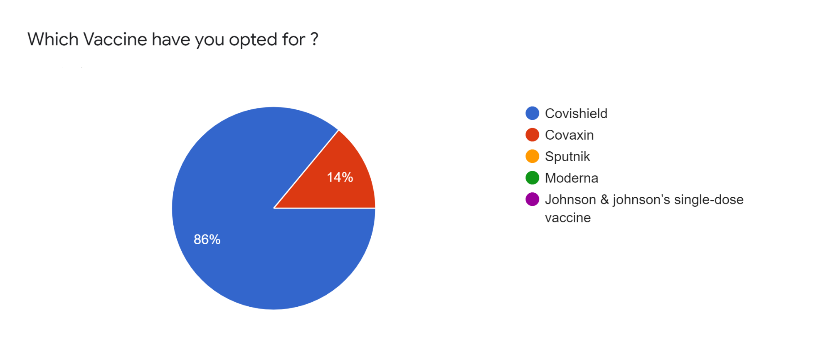
Figure 1.3.1.5

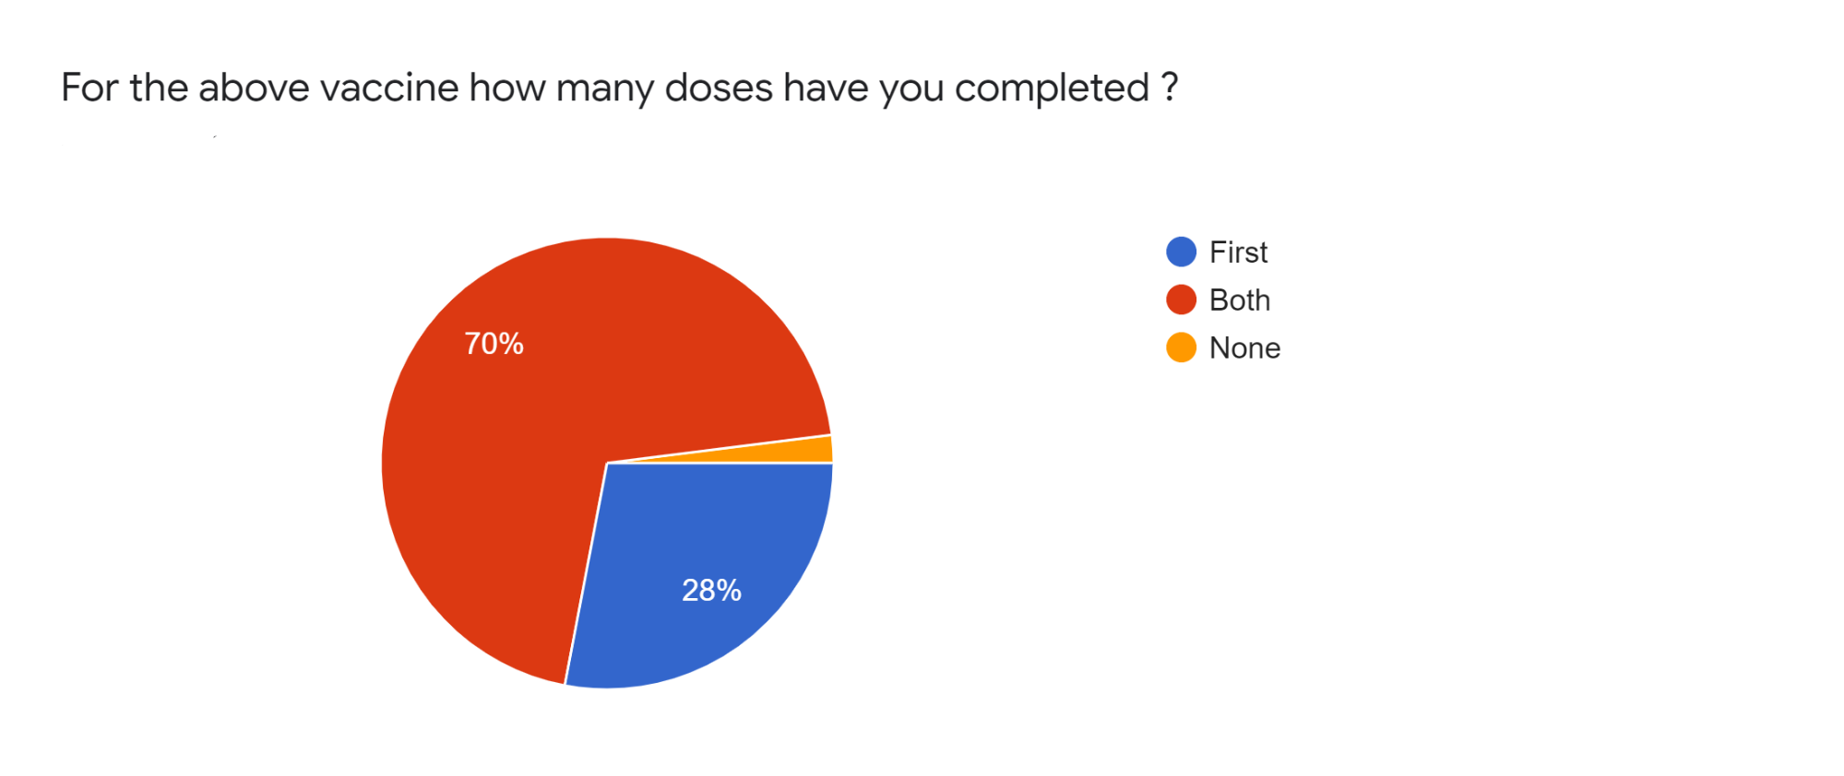
Figure 1.3.1.6

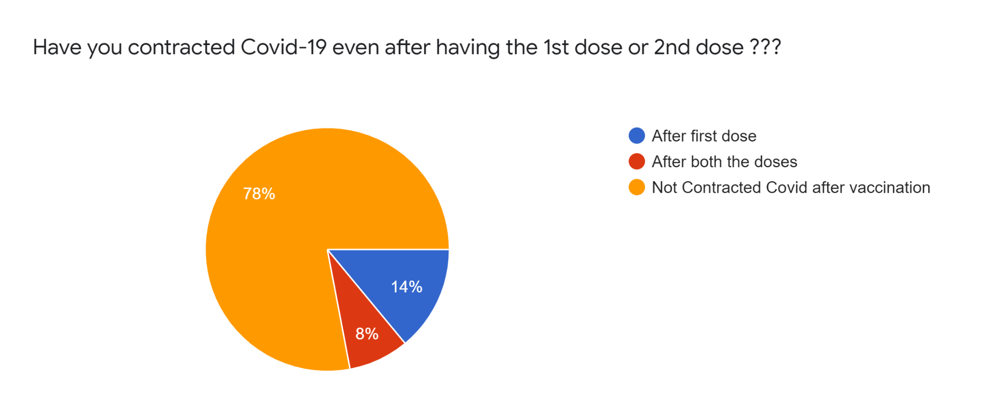
Figure 1.3.1.7

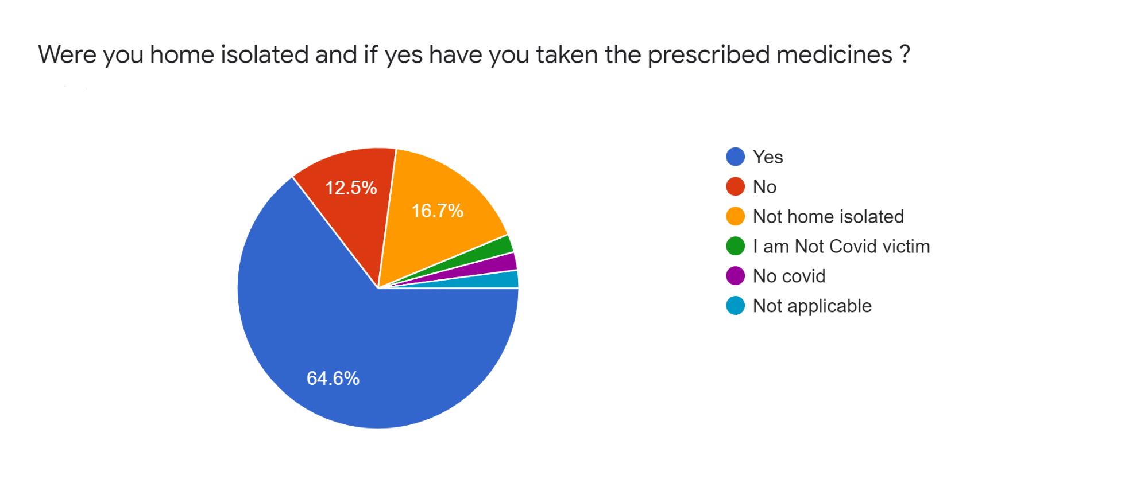
Figure 1.3.1.8

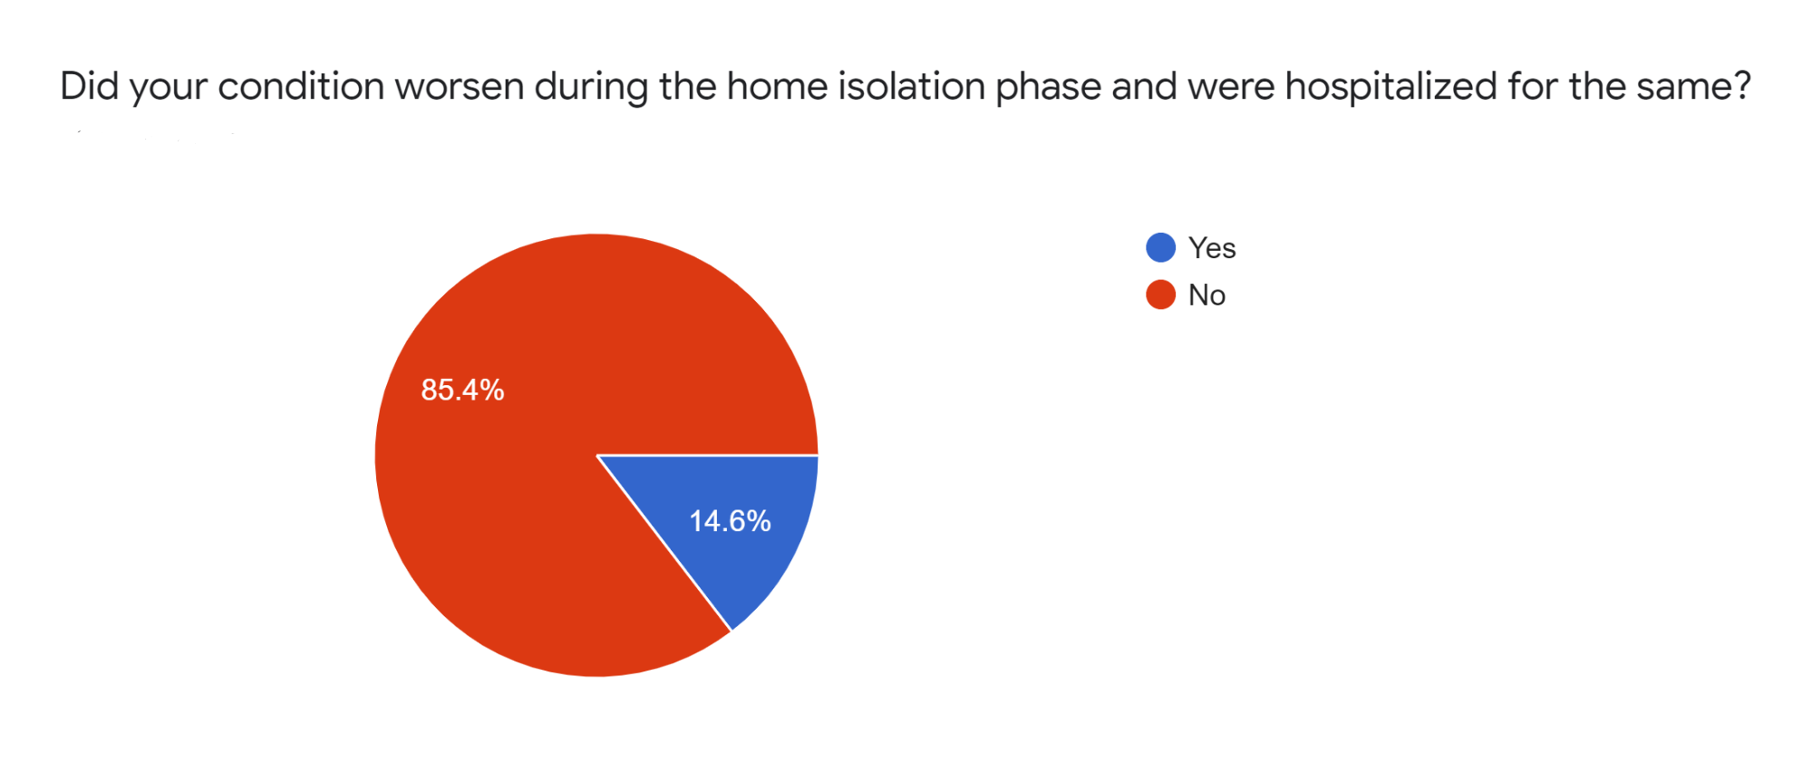
Figure 1.3.1.9

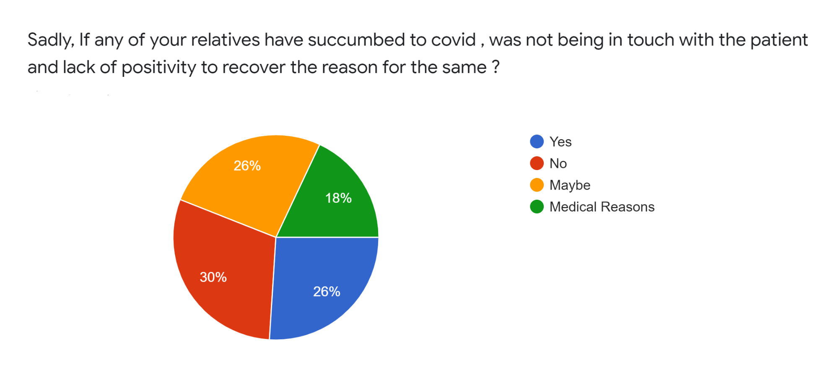
Figure 1.3.1.10

1.3.2 PREDICTION SYSTEM

As a part of our research, we have conducted several experiments to find the best model for the Pune region, all these experiments have shown us the importance of the region-specific factors that we have included in the dataset.

1.3.2.1 Single output model

In the results, we show the validation and test errors shown by the different models that we developed.

Experiment number | Model type | mean_absolute_error
1 | Linear model | 0.3995
2 | FNN model | 0.1769
3 | CNN model | 0.0965
4 | LSTM-RNN model | 0.0392

Table 1.3.2.1.1
From the table, we can see that the LSTM-RNN based model has outperformed all other models used.

The graphical representation of the errors is shown below:

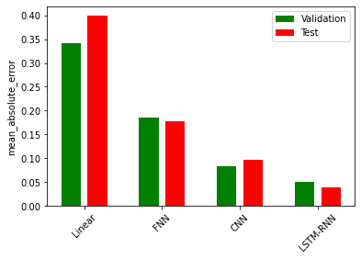
Figure 1.3.2.1.1

We can prediction made by the best performing model is shown in the below chart:

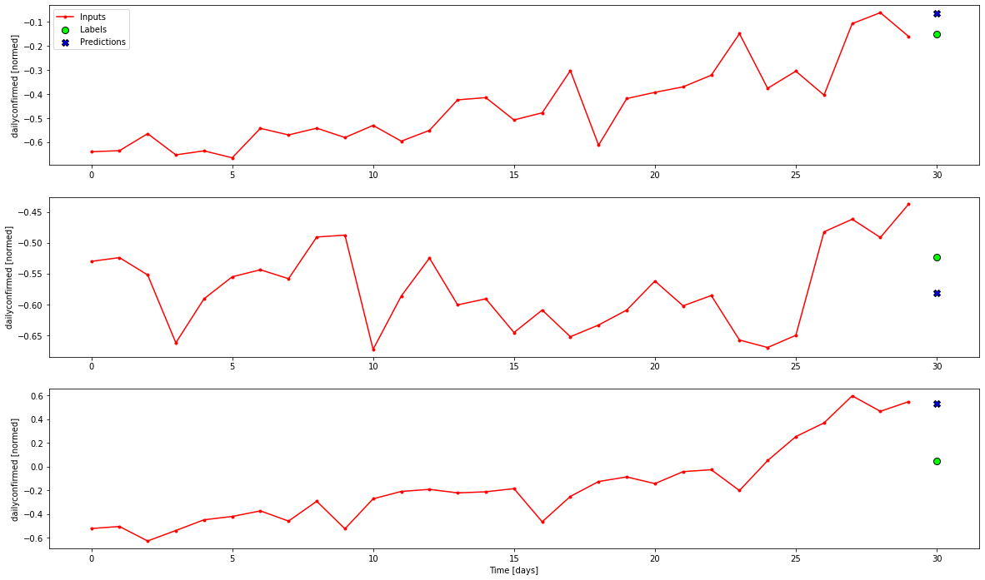
Figure 1.3.2.1.2

1.3.2.2 Multi-output model

We have experimented with the model with different hyperparameters and the best results were found in training the model with around 50 epochs.

Mean absolute error (average over all times and outputs): 0.4671

The model predictions are shown below :

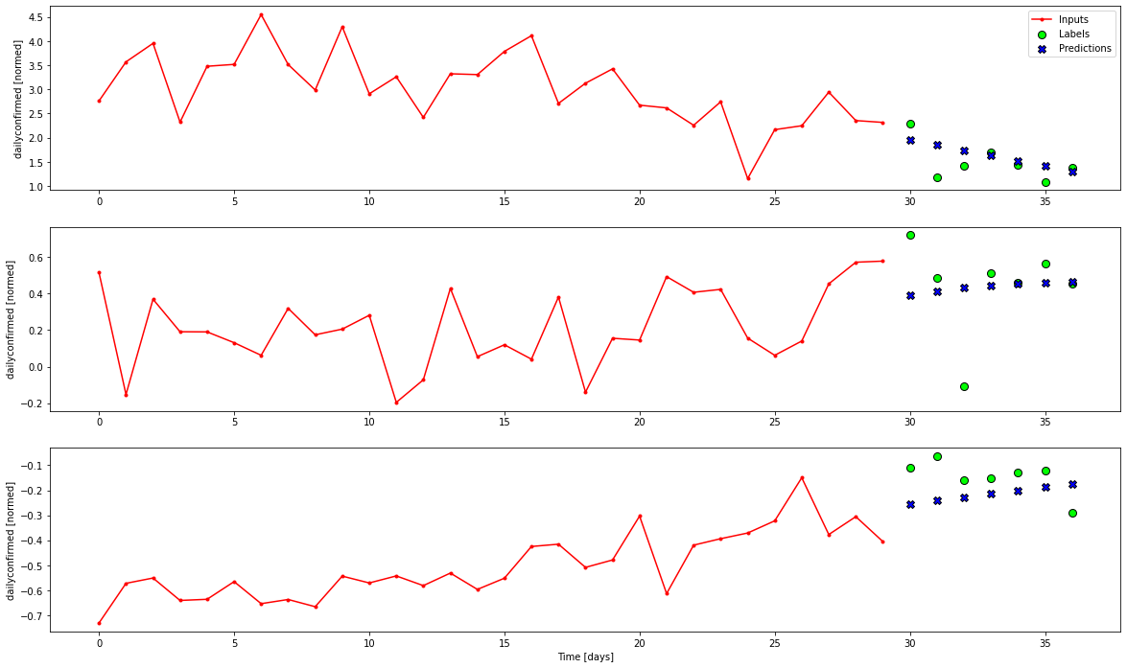
Figure 1.3.2.2.1

The above graph shows that the multi-output model has predicted some exact values and the rest of the values are near to the exact values.

1.3.3 RISK INDEX

1.3.3.1 Method 1 - Calculating Risk Index and Threshold

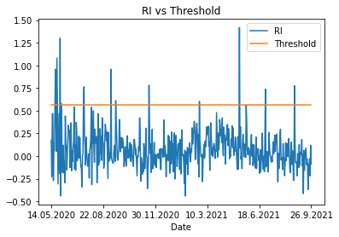
Figure 1.3.3.1.1

From the above graph, we can clearly see the days where the Risk index was less than the Threshold and greater than the threshold. Maximum risk index value was 1.41821 (above threshold) and it was on 11th May 2021 when Covid-19 cases were 2404. Minimum risk index value was -0.441669 (below threshold) and it was on 27th January 2021 when Covid-19 cases were 128. We can also see that RI was greater than the threshold for many times in 2020 as compared to 2021 till 26th September 2021. That means the severity of Covid-19 was greater in 2020 as compared to 2021. Recently RI was greater than the threshold on 25th August 2021 where RI value was 0.774805 and Covid-19 cases were 399. That means there is still Covid-19 third wave risk.

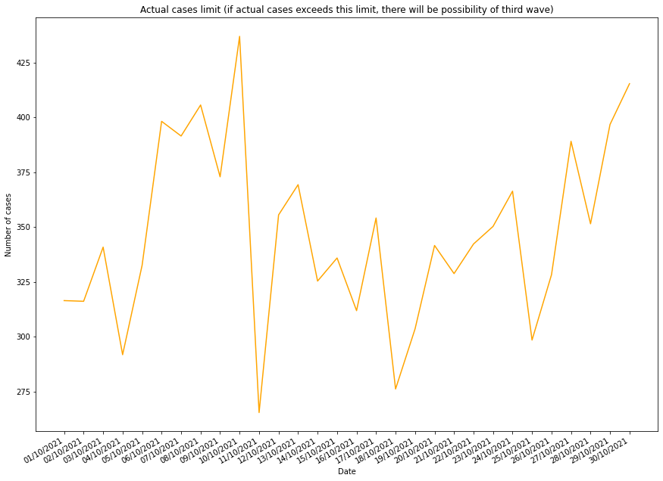
Figure 1.3.3.1.2

Above graph shows the actual cases limit for next month (October 2021). If the count of actual cases gets close to the actual cases limit or exceeds the actual cases limit , then the probability of a wave is high.

1.3.3.2 Method 2 - Calculating Risk Index without using threshold

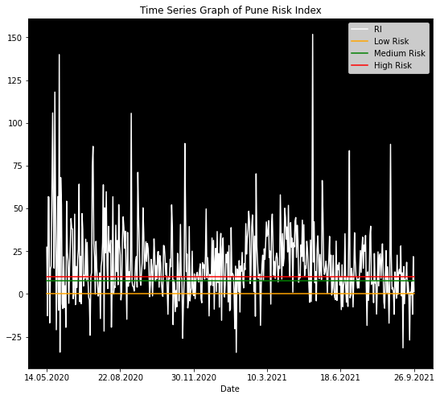
Figure 1.3.3.2.1

Above graph indicates the risk index for each day and lines showing low risk, medium risk and high risk. If the risk index lies between low to medium, it will be a safe situation for Covid-19.But if it consistently crosses the high risk line, there will be possibility of Covid-19 wave.

Dates from year 2020 | RI greater than 100(Huge Risk)
22.05.2020 | 105.82
25.05.2020 | 118.02
31.05.2020 | 139.94
6.09.2020 | 105.60

Table 1.3.3.2.1

Above table shows huge risk days from the year 2020 and their respective risk index.

Dates from year 2021 | RI greater than 80(Huge Risk)
11.5.2021 | 151.77
30.6.2021 | 83.77
25.8.2021 | 87.47

Table 1.3.3.2.2

Above table shows huge risk days from the year 2021 and their respective risk index.

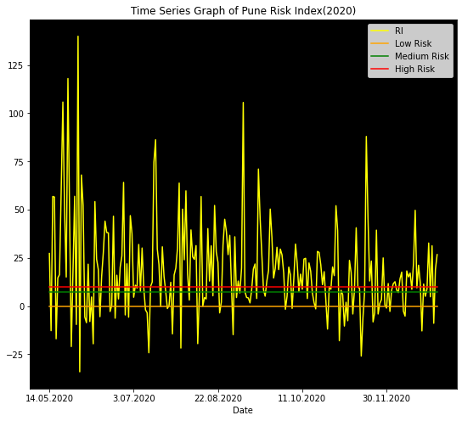

Figure 1.3.3.2.2

Above graph is showing the Pune risk index for each day for the year 2020. There were 136 days where the risk index crossed the high risk limit.

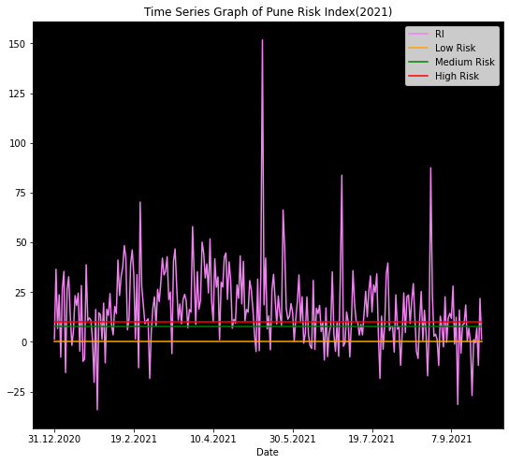
Figure 1.3.3.2.3

Above graph is showing the Pune risk index for each day for the year 2021. There were 166 days where the risk index crossed the high risk limit.By comparing both the graphs of the year 2020 and 2021, we can see many times the high risk limit has been crossed in 2021. It’s time to take precautions against Covid-19, to avoid further repercussions as we can see in the above graph, there is uncertainty, non-specific pattern in the risk index. It’s still above the high risk.

In such a way, we can observe and conclude many things by observing the graphs which are also included in the dashboard dynamically.

1.3.2 DASHBOARD

The following images represent the dashboard pages and their respective functionalities which also includes language translation option to translate the dashboard in Marathi (maximum spoken local language in Pune ).

Daily covid activities and predictions
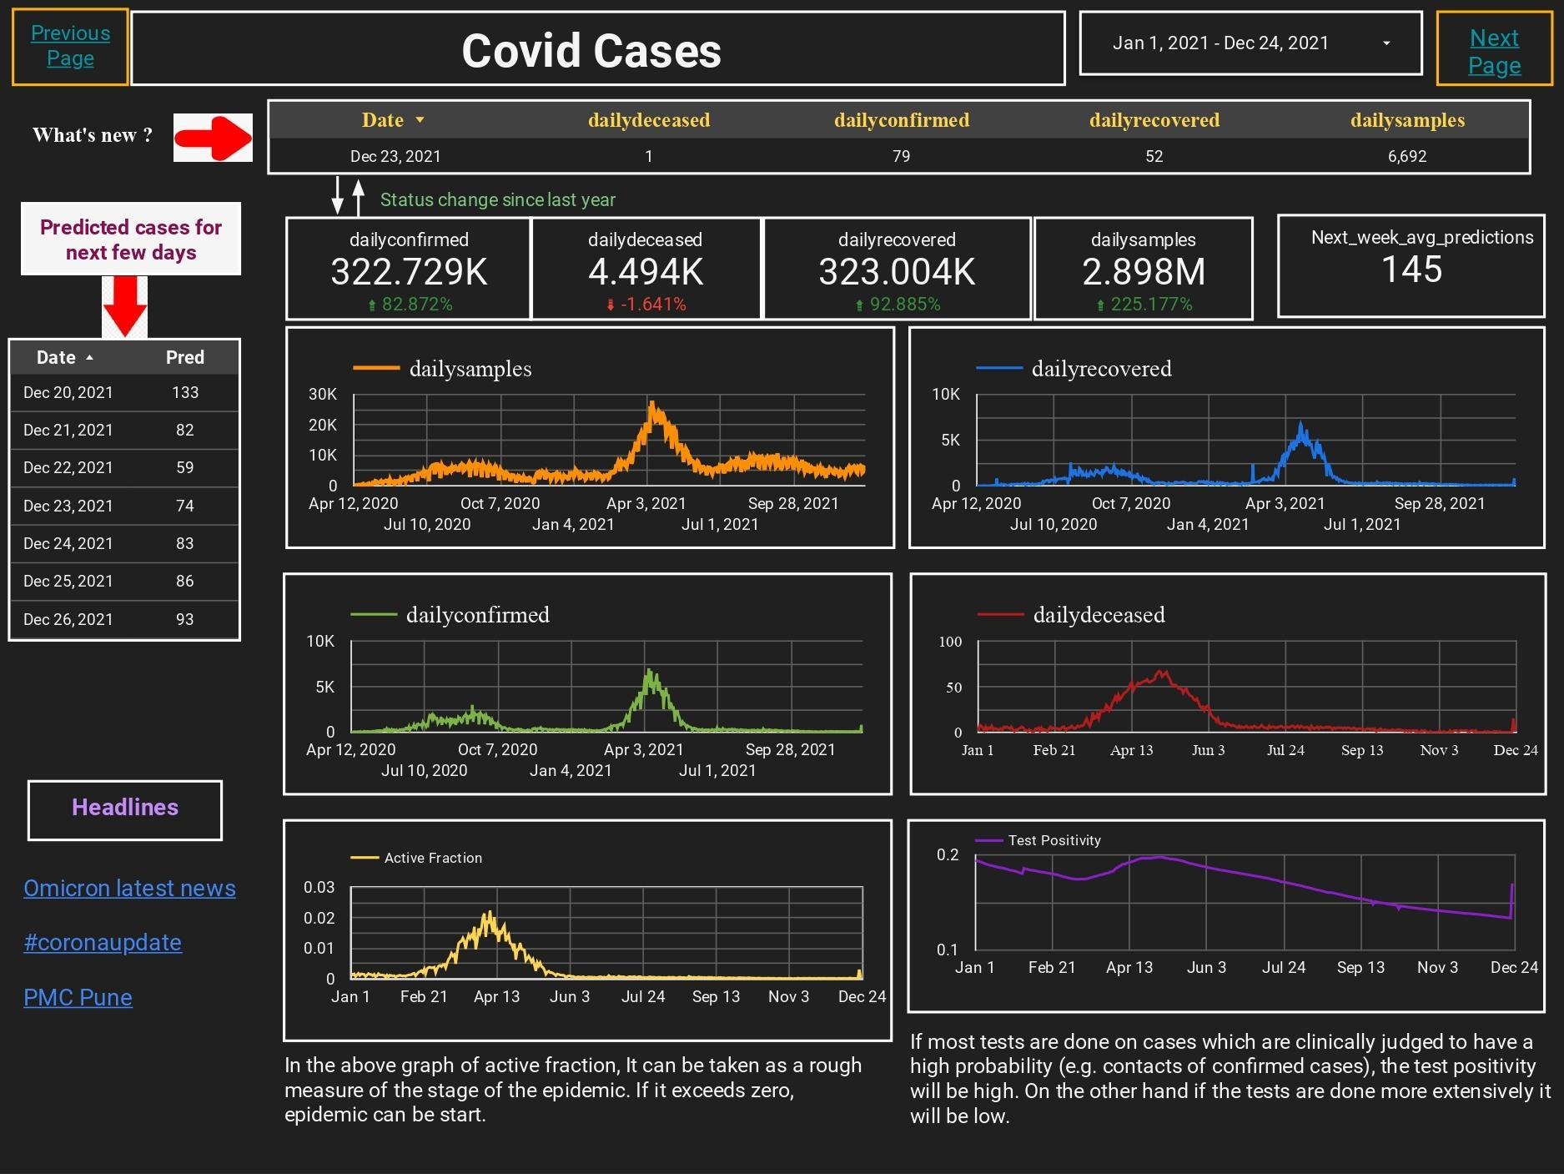
Figure 1.3.2.1

Risk index with threshold
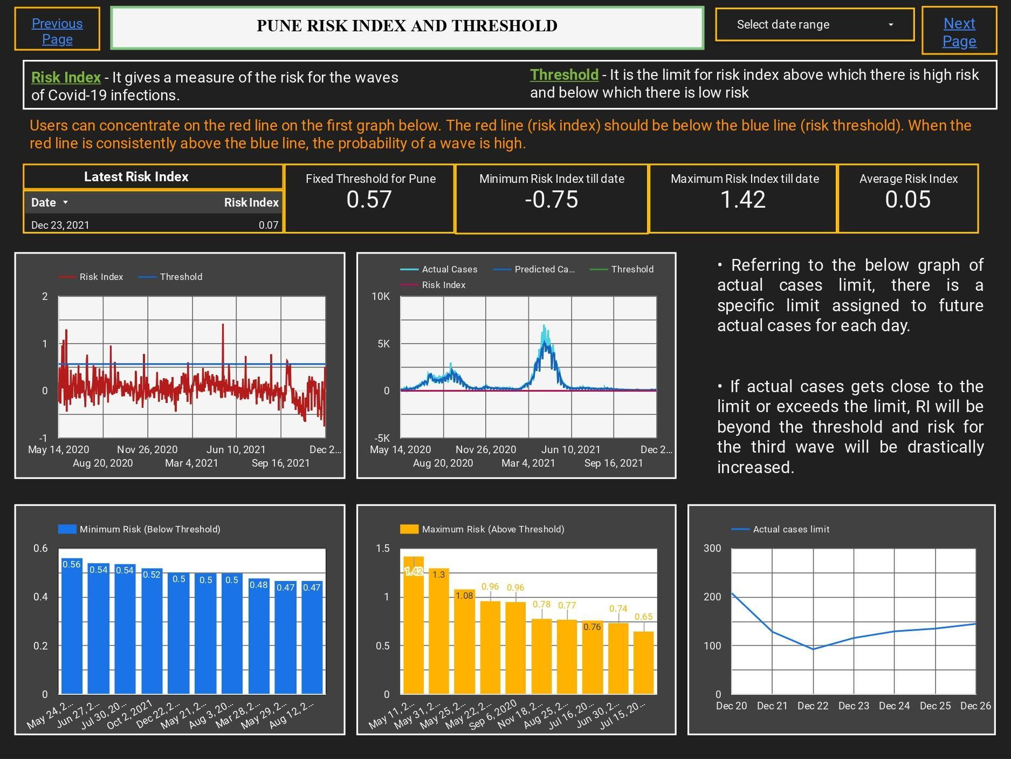
Figure 1.3.2.2

Risk index without threshold

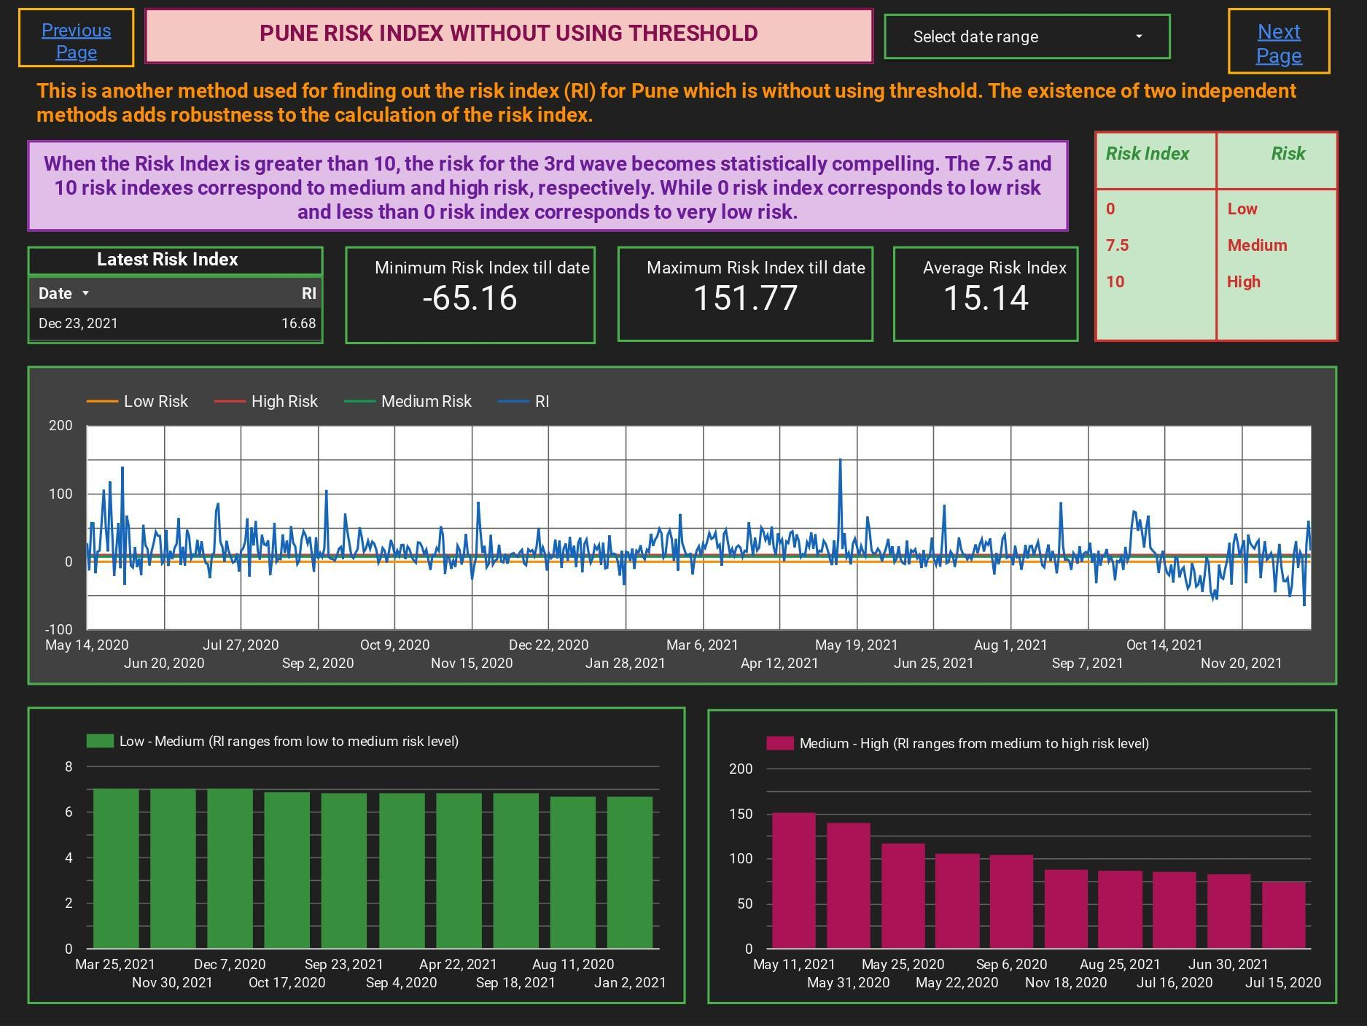
Figure 1.3.2.3

Mobility data
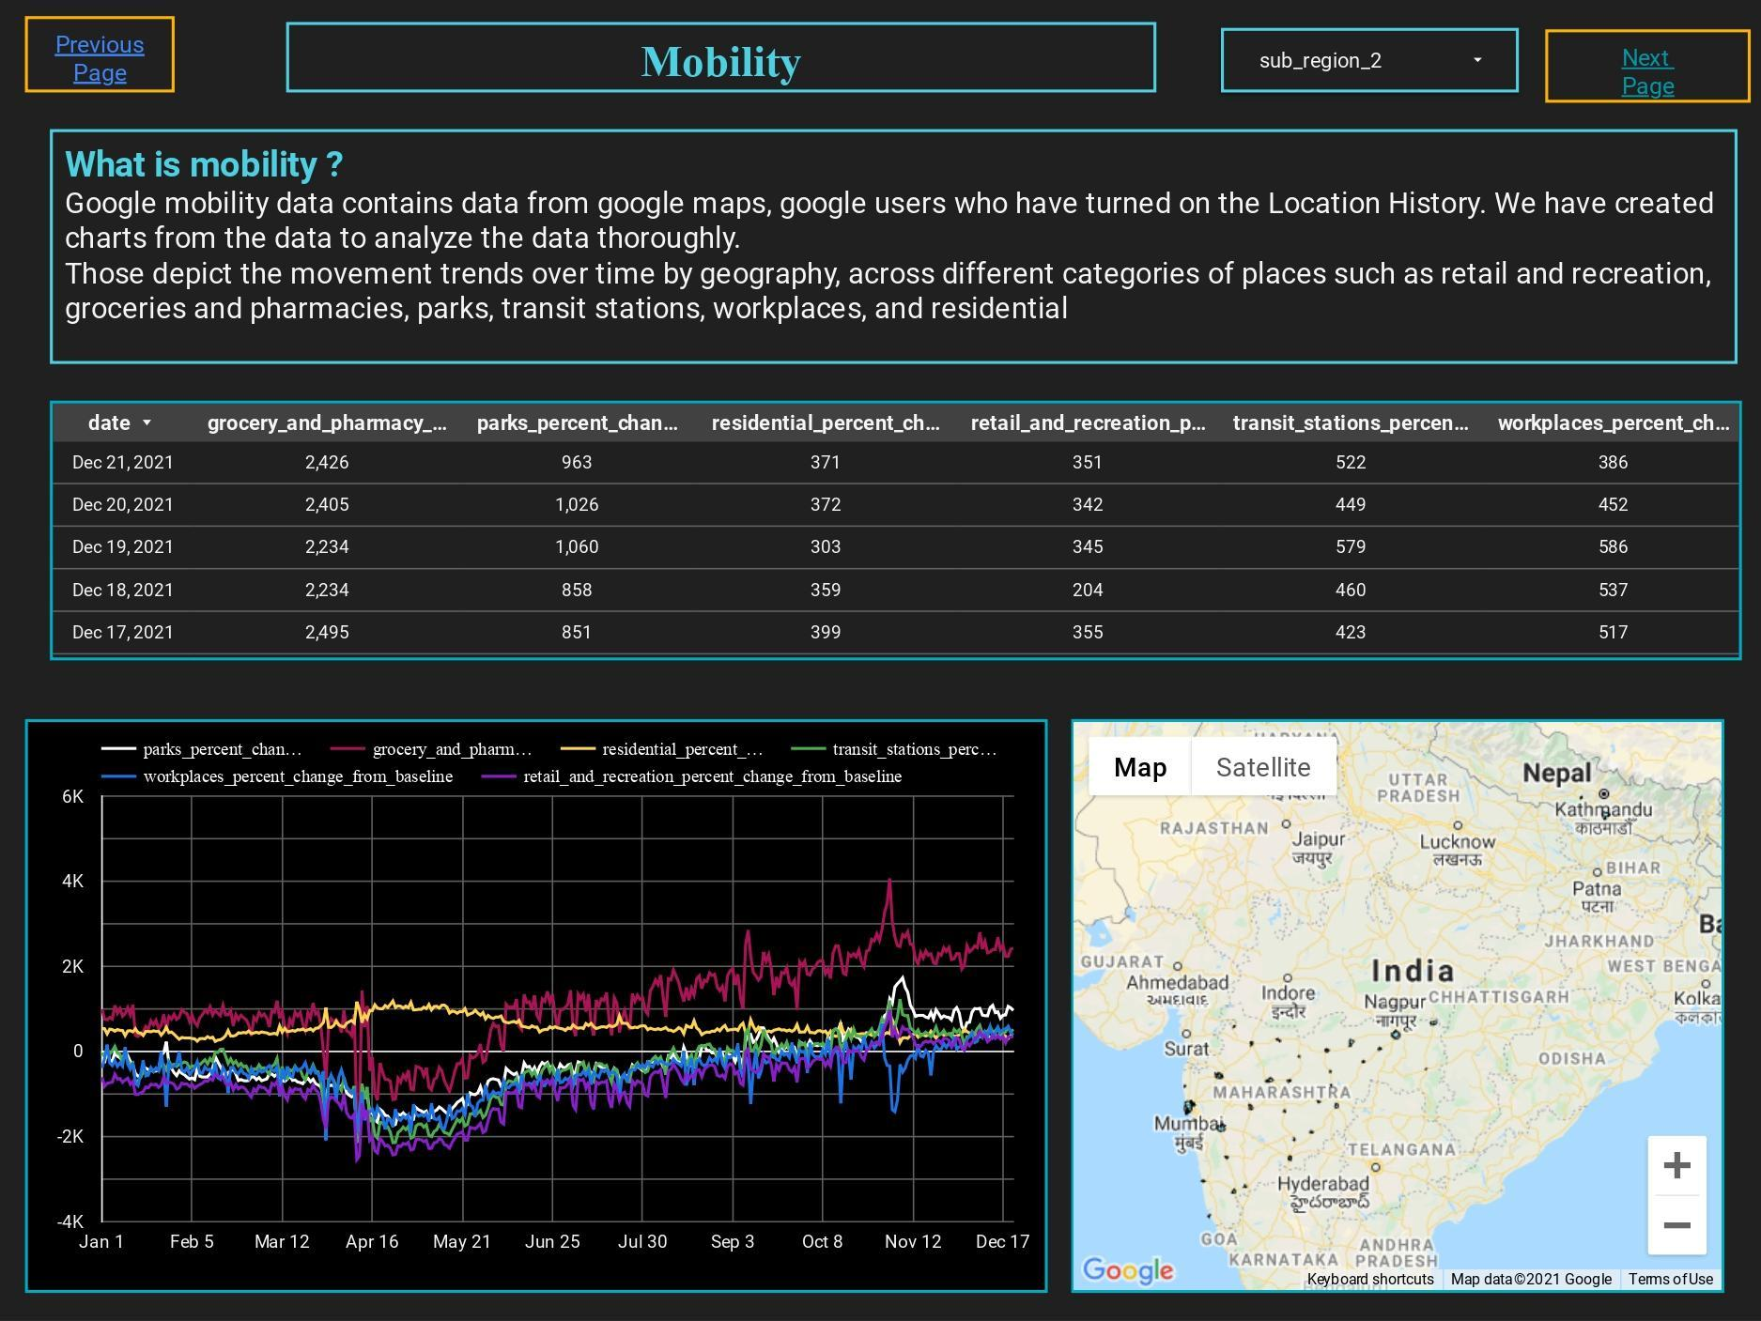

Figure 1.3.2.4

Region wise covid cases within PMC limits

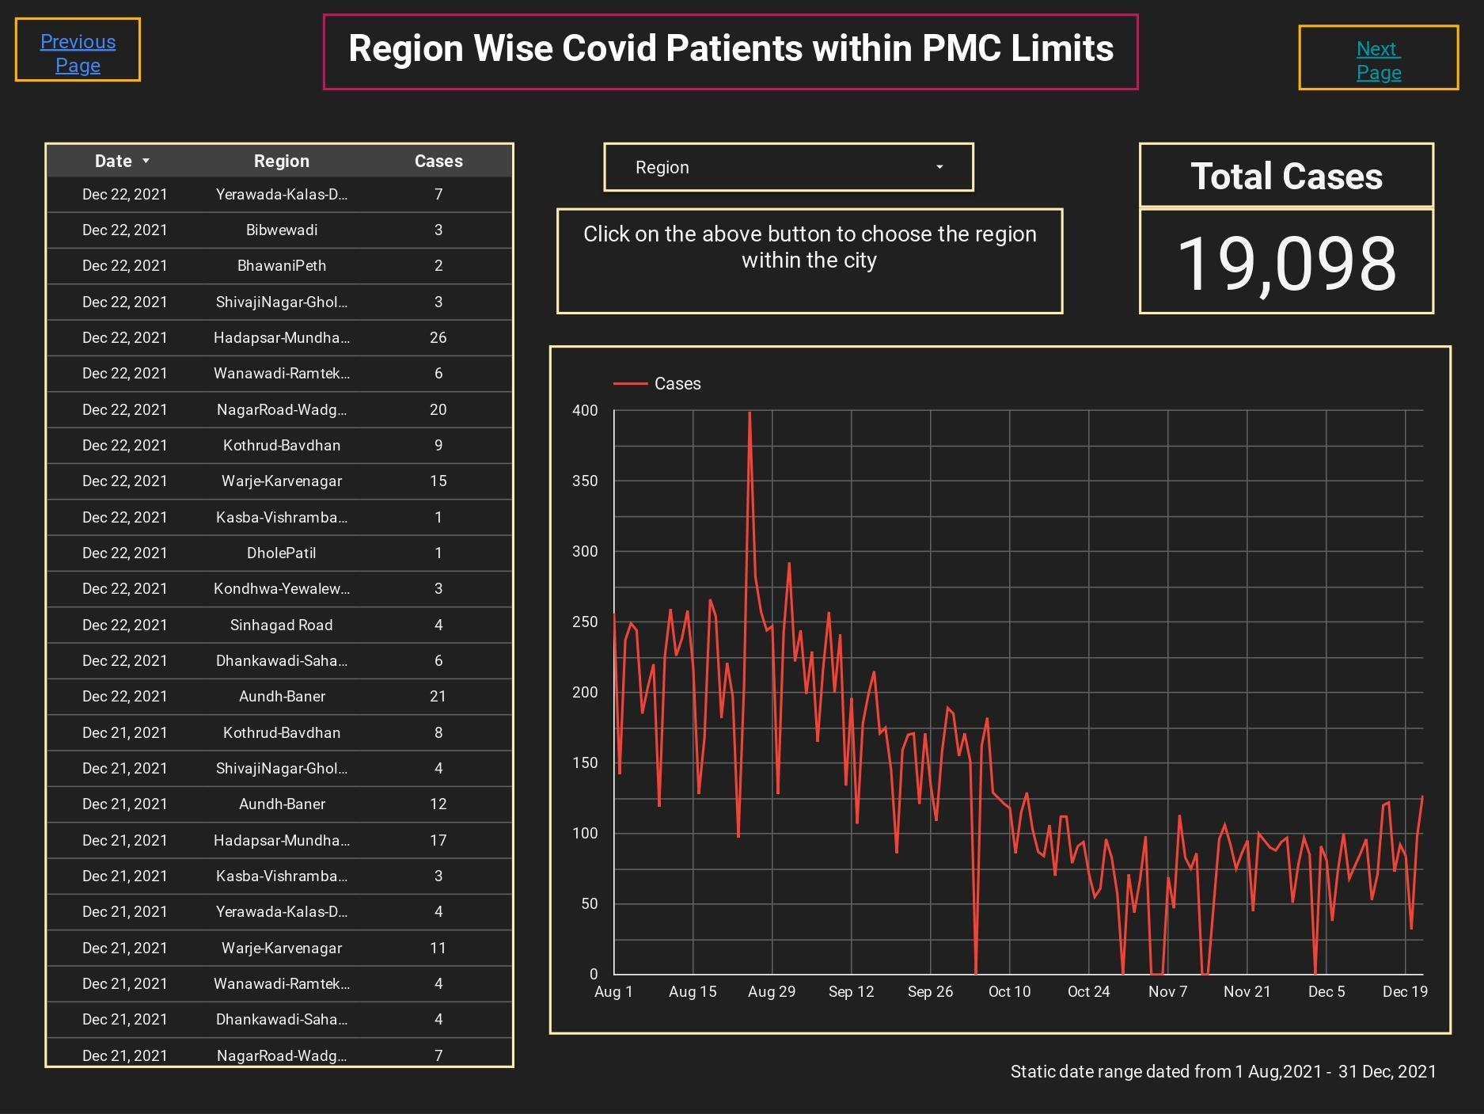
Figure 1.3.2.5

Pune vaccination trends

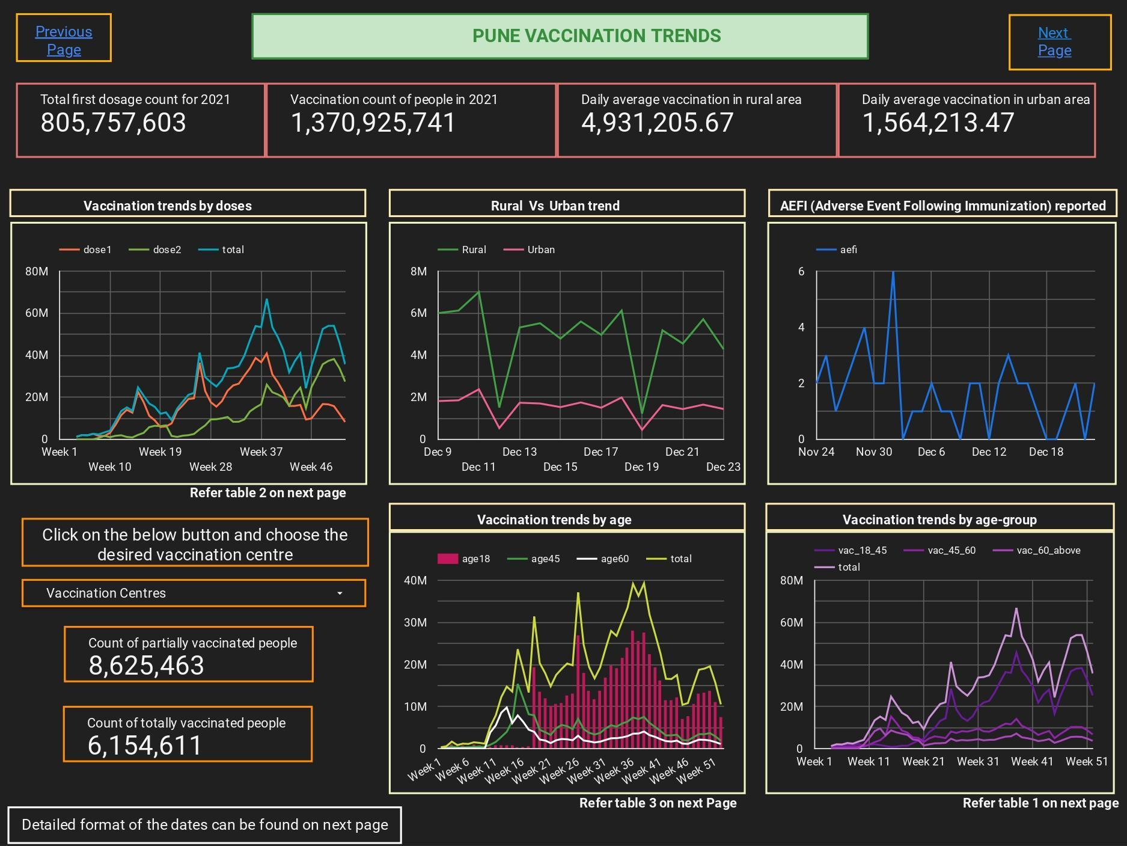
Figure 1.3.2.6

Vaccination in details

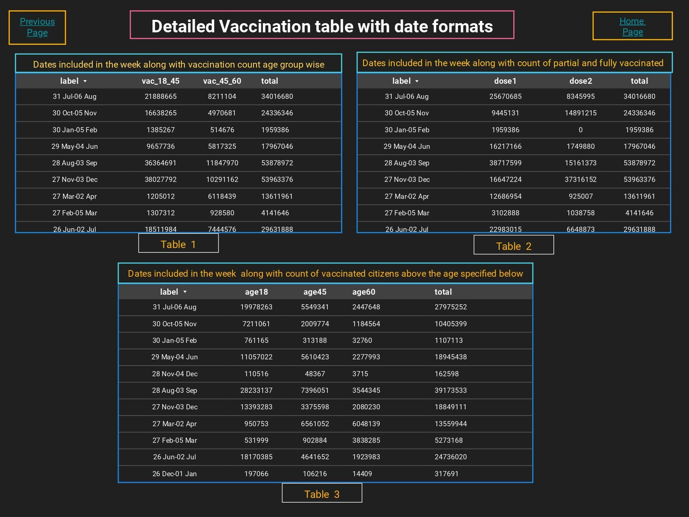
Figure 1.3.2.7

Translation in local language ( Marathi )

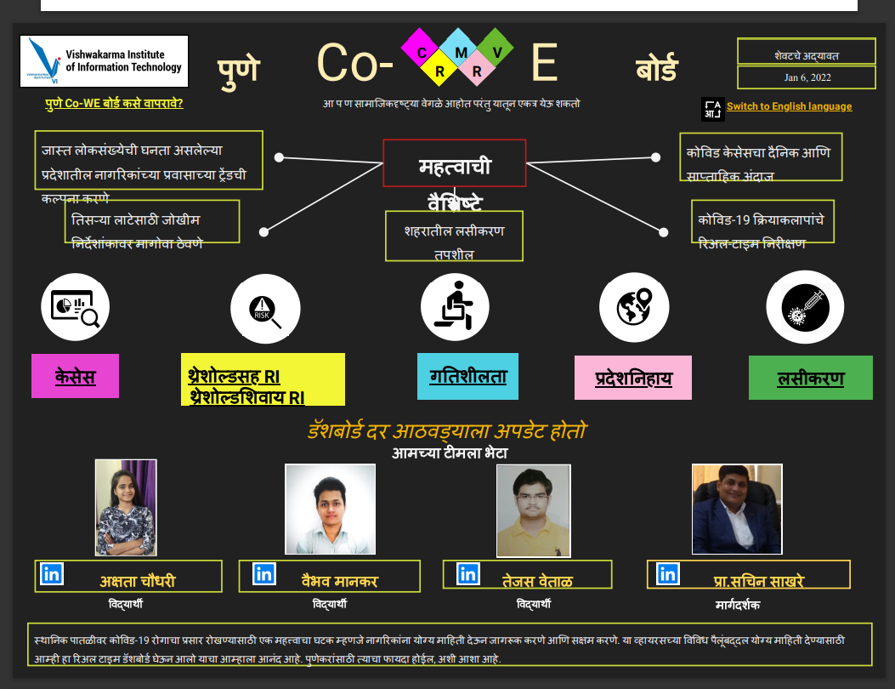

Figure 1.3.2.8

1.4. DISCUSSION / FUTURE TAKEAWAYS

As the number of patients with omicron variant is increasing day by day, chances of a third wave are increasing. It’s becoming essential to study Covid-19 disease thoroughly to avoid further repercussions. Our research gives the complete analysis, prediction of future cases, mobility trends across crowded places. It will be necessary for further precautions and actions against Covid-19 mainly in Pune. We have included risk index for Covid-19 third wave and for accurate prediction of the start of third wave and its duration, we will further try to use mathematical models.Here we mainly focused on Pune as it is one of the most covid vulnerable districts but further we can go for different regions in Maharashtra. We are looking forward to modifying our real time dashboard frequently according to the needs.

1.5. ACKNOWLEDGMENT

We are thankful to the R & D wing of Vishwakarma Institute Of Information Technology, Pune to provide the opportunity of a research internship under the guidance of Dr. Prof. Sachin Sakhare sir.

Dashboard Link : https://pune-co-we-board.herokuapp.com/

Associative data and code can be found here : https://github.com/CovidDashboardProject

References

- En.wikipedia.org. 2021. Linear model - Wikipedia. [online] Available at: <https://en.wikipedia.org/wiki/Linear_model> [Accessed 22 December 2021].
- Svozil, Daniel, Vladimir Kvasnicka, and Jiri Pospichal. "Introduction to multi-layer feed-forward neural networks." Chemometrics and intelligent laboratory systems 39, no. 1 (1997): 43-62.
- Albawi, Saad, Tareq Abed Mohammed, and Saad Al-Zawi. "Understanding of a convolutional neural network." In 2017 International Conference on Engineering and Technology (ICET), pp. 1-6. Ieee, 2017.
- Medsker, Larry R., and L. C. Jain. "Recurrent neural networks." Design and Applications 5 (2001): 64-67.
- En.wikipedia.org. 2021. Autoregressive model - Wikipedia. [online] Available at: <https://en.wikipedia.org/wiki/Autoregressive_model> [Accessed 22 December 2021].
- Gers, Felix A., Douglas Eck, and Jürgen Schmidhuber. "Applying LSTM to time series predictable through time-window approaches." In Neural Nets WIRN Vietri-01, pp. 193-200. Springer, London, 2002.
- Brownlee, J., 2021. Time Series Forecasting as Supervised Learning. [online] Machine Learning Mastery. Available at: <https://machinelearningmastery.com/time-series-forecasting-supervised-learning/#:~:text=The%20use%20of%20prior%20time,or%20size%20of%20the%20lag.> [Accessed 22 December 2021].
- En.wikipedia.org. 2021. Linear predictor function - Wikipedia. [online] Available at: <https://en.wikipedia.org/wiki/Linear_predictor_function> [Accessed 22 December 2021].
- Li, D., Hasanaj, E. and Li, S., 2021. 3 - Baselines. [online] Machine Learning Blog | ML@CMU | Carnegie Mellon University. Available at: <https://blog.ml.cmu.edu/2020/08/31/3-baselines/> [Accessed 22 December 2021].
- Ibrahim, Yahya & Alhamdany, Thamir & Ibraheem, I. (2009). An Algorithm For The Best Way Connection Among Cell-Phone Towers Using Feedforward Neural Network.
- Brownlee, J., 2021. A Gentle Introduction to the Rectified Linear Unit (ReLU). [online] Machine Learning Mastery. Available at: <https://machinelearningmastery.com/rectified-linear-activation-function-for-deep-learning-neural-networks/> [Accessed 22 December 2021].
- En.wikipedia.org. 2021. Convolution - Wikipedia. [online] Available at: <https://en.wikipedia.org/wiki/Convolution> [Accessed 22 December 2021].
- Liddy, Elizabeth D. "Natural language processing." (2001).
- Bowman, Samuel R., Luke Vilnis, Oriol Vinyals, Andrew M. Dai, Rafal Jozefowicz, and Samy Bengio. "Generating sentences from a continuous space." arXiv preprint arXiv:1511.06349 (2015).
- Friston, Karl John, Christopher Donald Frith, P. F. Liddle, and R. S. J. Frackowiak. "Investigating a network model of word generation with positron emission tomography." Proceedings of the Royal Society of London. Series B: Biological Sciences 244, no. 1310 (1991): 101-106.
- CESSI COVID-19 Dashboard. 2021. CESSI COVID-19 Dashboard. [online] Available at: <http://www.cessi.in/coronavirus/pune> [Accessed 22 December 2021].
- 2021. [online] Available at: <https://www.imdpune.gov.in/> [Accessed 22 December 2021].
- COVID-19 Community Mobility Report. 2021. COVID-19 Community Mobility Report. [online] Available at: <https://www.google.com/covid19/mobility/> [Accessed 22 December 2021].
- Datastudio.google.com. 2021. Google Data Studio Overview. [online] Available at: <https://datastudio.google.com/> [Accessed 22 December 2021].
- Python.org. 2021. Welcome to Python.org. [online] Available at: <https://www.python.org/> [Accessed 22 December 2021].
- Flask.palletsprojects.com. 2021. Welcome to Flask — Flask Documentation (2.0.x). [online] Available at: <https://flask.palletsprojects.com/en/2.0.x/> [Accessed 22 December 2021].
- En.wikipedia.org. 2021. Google Sheets - Wikipedia. [online] Available at: <https://en.wikipedia.org/wiki/Google_Sheets> [Accessed 22 December 2021].
- Dashboard.heroku.com. 2021. Heroku. [online] Available at: <https://dashboard.heroku.com/login> [Accessed 22 December 2021].
- Dashboard.cowin.gov.in. 2021. CoWIN Dashboard. [online] Available at: <https://dashboard.cowin.gov.in/> [Accessed 24 December 2021].
- "Wind Direction And Degrees ". 2021. Snowfence.Umn.Edu. http://snowfence.umn.edu/Components/winddirectionanddegrees.htm.
- 2021. https://www.covid19sa.org/ [Accessed 29 September 2021].
- "Covid Burden Higher In Pune In 2Nd Wave But CFR Declined Over Time: Study". 2021. The Indian Express. https://indianexpress.com/article/cities/pune/pune-covid-second-wave-fatality-rate-7390479/.
- Brath, Richard, And Michael Peters. "Dashboard Design: Why Design Is Important." DM Direct 85 (2004): 1011285-1. Ebook, 2021.
- "What Is The Purpose Of A Dashboard? | Idashboards". Idashboards |, 2021. https://www.idashboards.com/blog/2016/09/26/what-is-the-purpose-of-a-dashboard-2/.
- The effect of interactive analytical dashboard features on situation awareness and task performance (nih.gov) [ Accessed 20 December 2021 ]
- "Short Report – COVID-19 And Weather Parameters: Pune, India". 2022. European Review. https://www.europeanreview.org/article/23241[ Accessed 3 January 2022 ].
- News, City, and Pune News. 2022. "High Monsoon Humidity Linked To Covid Rise In Pune, Mumbai, Delhi: IITM Study | Pune News - Times Of India". The Times Of India. https://timesofindia.indiatimes.com/city/pune/high-monsoon-humidity-linked-to-covid-rise-in-pune-mumbai-delhi-iitm-study/articleshow/86021041.cms[ Accessed 3 January 2022 ].

